Traffic Flow Management System (TFMS) ER Diagram Design Project

Deliverables

**1. ER Diagram :**

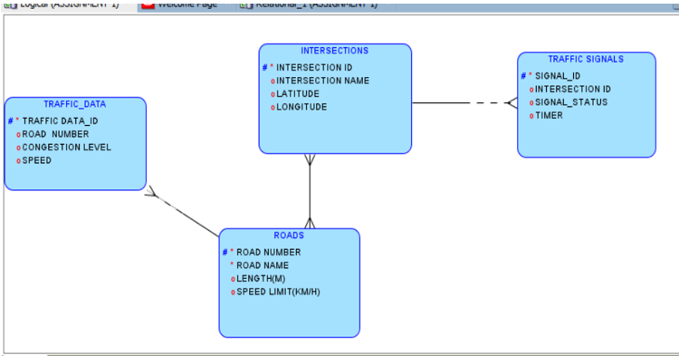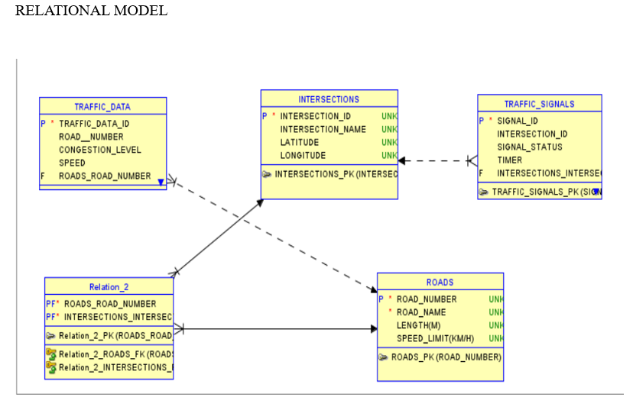

**2. Entity Definitions**

**Extended Entity Definitions**

**1. Roads**

- RoadID (PK): Unique identifier for each road.

- RoadName: The name of the road, such as "Main Street" or "Highway 101".

- Length: The length of the road in meters, useful for calculating travel times and distances.

- SpeedLimit: The maximum allowed speed on the road in kilometers per hour, crucial for traffic regulations and safety measures.

**2. Intersections**

- IntersectionID (PK): Unique identifier for each intersection.

- IntersectionName: A descriptive name for the intersection, such as "5th and Main".

- Latitude: The geographic latitude coordinate of the intersection, aiding in precise location mapping.

- Longitude: The geographic longitude coordinate of the intersection, aiding in precise location mapping.

**3. Traffic Signals**

- SignalID (PK): Unique identifier for each traffic signal.

- IntersectionID (FK): Foreign key linking the traffic signal to an intersection.

- SignalStatus: Current state of the signal (Green, Yellow, Red), critical for traffic control.

- Timer: Countdown timer indicating when the signal will change, essential for managing traffic flow and signal synchronization.

**4. Traffic Data**

- TrafficDataID (PK): Unique identifier for each traffic data entry.

- RoadID (FK): Foreign key linking the traffic data to a specific road.

- Timestamp: The date and time when the traffic data was recorded, important for time-based analysis.

- Speed: The average speed of vehicles on the road at the time of data collection, useful for assessing traffic flow.

- CongestionLevel: Degree of traffic congestion (e.g., Low, Medium, High), important for real-time traffic management and route optimization.

**Additional Considerations**

**Historical Traffic Data**

To support historical analysis and planning, we can introduce a new entity:

**Historical Traffic Data**

- HistoricalDataID (PK): Unique identifier for each historical traffic data entry.

- RoadID (FK): Foreign key linking the historical data to a specific road.

- Date: The date of the recorded traffic data, useful for long-term trend analysis.

- AverageSpeed: The average speed recorded on that date.

- AverageCongestionLevel: The average congestion level recorded on that date.

**Sensors and Cameras**

Integrating sensors and cameras can enhance real-time data collection:

**Sensors**

**-** SensorID (PK): Unique identifier for each sensor.

- RoadID (FK): Foreign key linking the sensor to a specific road.

- Type: The type of sensor (e.g., speed sensor, traffic density sensor).

- Status: Operational status of the sensor (e.g., Active, Inactive).

- InstallationDate: The date the sensor was installed.

**Cameras**

- CameraID (PK): Unique identifier for each camera.

- IntersectionID (FK): Foreign key linking the camera to a specific intersection.

- Resolution: The resolution of the camera, important for image quality.

- Status: Operational status of the camera (e.g., Active, Inactive).

- InstallationDate: The date the camera was installed.

**User Interaction**

To manage the system effectively, a user entity can be introduced:

**Users**

- UserID (PK): Unique identifier for each user.

- UserName: The name of the user.

- Role: The role of the user (e.g., Administrator, Traffic Manager).

- Email: The email address of the user.

- Password: The password for user authentication.

By defining these entities and their attributes, the TFMS database structure becomes comprehensive, supporting various functionalities such as real-time traffic management, historical data analysis, and system administration. This extended definition ensures a robust and scalable design, capable of addressing the city’s traffic management needs effectively.

**3. Relationship Descriptions**

Detailed Relationship Descriptions

**1. Roads to Intersections**

- Relationship: Roads connect to multiple Intersections.

- Cardinality: One-to-many (One Road can have many Intersections).

- Optionality: Mandatory for Intersections to connect to Roads.

- Description: Each road in the city's network will intersect with one or more intersections. This relationship helps in identifying all intersections that lie on a specific road, facilitating route management and optimization.

**2. Intersections to Traffic Signals**

- Relationship: Intersections host multiple Traffic Signals.

- Cardinality: One-to-many (One Intersection can have many Traffic Signals).

- Optionality: Mandatory for Traffic Signals to connect to Intersections.

- Description: Each intersection is equipped with multiple traffic signals to manage traffic flow from different directions. This relationship ensures that traffic signals are correctly associated with their respective intersections, allowing for accurate traffic signal control.

**3. Roads to Traffic Data**

- Relationship: Roads have associated Traffic Data collected over time.

- Cardinality: One-to-many (One Road can have many Traffic Data entries).

- Optionality: Mandatory for Traffic Data to connect to Roads.

- Description: Traffic data is collected periodically for each road, capturing real-time traffic conditions such as speed and congestion levels. This relationship enables the system to store and analyze traffic data for each road, aiding in route optimization and traffic management.

**4. Roads to Sensors**

- Relationship: Roads are monitored by multiple Sensors.

- Cardinality: One-to-many (One Road can have many Sensors).

- Optionality: Optional for Sensors to connect to Roads.

- Description: Sensors installed along roads capture various traffic parameters like speed and density. This relationship helps in mapping which sensors are associated with which roads, ensuring accurate real-time data collection.

**5. Intersections to Cameras**

- Relationship: Intersections are monitored by multiple Cameras.

- Cardinality: One-to-many (One Intersection can have many Cameras).

- Optionality: Optional for Cameras to connect to Intersections.

- Description: Cameras installed at intersections capture visual traffic data, enhancing monitoring and control. This relationship ensures that each camera is linked to its respective intersection for proper traffic management.

6**. Intersections to Historical Traffic Data**

- Relationship: Historical traffic data can be aggregated at intersections.

- Cardinality: One-to-many (One Intersection can have many Historical Traffic Data entries).

- Optionality: Mandatory for Historical Traffic Data to connect to Intersections.

- Description: Historical traffic data provides insights into past traffic patterns at intersections, helping in future traffic planning and management. This relationship links historical data to specific intersections.

**7. Users to Traffic Signals**

- Relationship: Users manage multiple Traffic Signals.

- Cardinality: One-to-many (One User can manage many Traffic Signals).

- Optionality: Optional for Traffic Signals to be connected to Users.

- Description: Users with roles such as Traffic Managers can control and adjust traffic signals. This relationship allows tracking of which users are responsible for managing specific traffic signals.

**8. Users to Traffic Data**

- Relationship: Users can input or analyze multiple Traffic Data entries.

- Cardinality: One-to-many (One User can interact with many Traffic Data entries).

- Optionality: Optional for Traffic Data to be connected to Users.

- Description: Users can input real-time traffic data or analyze existing data for reports and decision-making. This relationship tracks user interactions with traffic data entries.

Summary of Relationships and Their Importance

**4. Justification Document**

**Design Choices Justification:**

**1. Scalability:**

- The design ensures scalability by separating entities and establishing clear relationships. This modular approach allows the system to expand as the city’s road network and traffic data grow without requiring significant redesign.

**2. Real-Time Data Processing:**

- Real-time data integration is supported by the Traffic Data entity, which stores timestamped entries for each road. This setup allows for efficient data retrieval and analysis to make timely traffic management decisions.

**3. Efficient Traffic Management:**

- The design supports key functionalities like route optimization and traffic signal control by linking real-time data with traffic signals and intersections. This linkage enables adaptive control algorithms to adjust signal timings based on current traffic conditions.

**Normalization Considerations:**

**1. First Normal Form (1NF**):

- All entities are designed to have atomic attributes, ensuring no repeating groups or multi-valued attributes. For example, each Traffic Data entry is linked to a single RoadID and has a unique TrafficDataID.

**2. Second Normal Form (2NF):**

- The design eliminates partial dependencies by ensuring all non-key attributes are fully functionally dependent on the primary key. For instance, attributes like Length and SpeedLimit in the Roads entity depend entirely on RoadID.

**3. Third Normal Form (3NF):**

- The design removes transitive dependencies by ensuring that non-key attributes are not dependent on other non-key attributes. For example, Traffic Signal attributes like SignalStatus and Timer depend only on SignalID and not on IntersectionID directly.

Project Conclusion

The ER diagram for the Traffic Flow Management System (TFMS) is designed to address the city's traffic congestion issues by optimizing traffic routes, managing intersections, and controlling traffic signals. By integrating real-time data and historical traffic patterns, the system supports intelligent traffic management solutions, enhancing transportation efficiency. The design adheres to normalization principles, ensuring minimal redundancy and improved data integrity while being scalable and capable of processing real-time data efficiently.